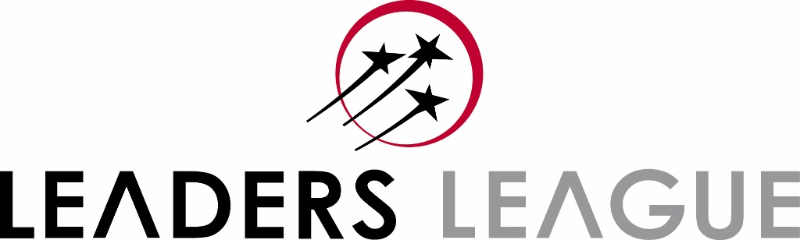

FINTECH
Practice Area Description: This area covers technology-centric work on behalf of financial institutions; financial advice given to technology companies; and general regulatory work pertaining to the intersection between technology and finance or insurance. Corporate and M&A work involving fintech companies will be considered but is less important for this ranking.

This form can be filled in using English or French

Please send the forms and referee lists to switzerland@leadersleague.com

- Firm’s Information

Firm’s Name
Year of Establishment
Name of the Managing Partner
Name of the person(s) in charge of Marketing/Business Development
List of Offices

Composition of the firm:
Number of Partners | Number of Counsels/Associates

- Department Information

Name of the Partner(s) in charge of completing this form

Name of the Head(s) of the department and other key partners in order of importance/seniority:
Highlight in RED the partners who dedicate less than 50% of their time to this department.

Name | E-mail | Partner Since | Comments

Composition of the department:
Number of Male Partners | Number of Female Partners | Number of Counsels/Associates

Please tell us about any changes in this department at partner, counsel or senior associate level over the last 12 months. This includes arrivals, departures, partner promotions and retirements. Feel free to add rows if necessary.

Name | Position | Arrived/left/promoted/retired? | Moved to/from where? | Month and year

What is your department best known for? (500 words max.)
Specific expertise, types of mandates, industry sectors, renowned practitioners, etc.

How many new cases in this specific practice area did your firm take on in the last 12 months?

Top five sectors your department works with:

1.
2.
3.
4.
5.

List of active clients (up to 30, in order of importance). Please highlight any new clients in the list.

Company | Sector | New Client (Y/N) | Confidential (Y/N) | Type of Work
1.
2.
3.
4.
5.
6.
7.
8.
9.
10.
…
30.

- Referees

Please fill out the specific form attached with the contact details of your in-house referees.
Do note that when contacting clients, we will not mention you or your firm.

- 1. Peer Feedback

Fintech: Established Practitioners

In your opinion, which are the leading law firms/lawyers in Fintech?
Firm / Lawyer | Comments

Fintech: Rising Stars (Law Firms)

In your opinion, who are the rising stars in this practice? (i.e. young teams with an increasing presence and reputation)

Law Firm | Lawyers | Main Specialty

E. Feedback

What is your opinion of your firm’s current position in Leaders League’s Fintech ranking?

- Work Highlights

Guidelines

- To be eligible, cases must have been ongoing between June 19th, 2023 and June 19th, 2024.

- Any piece of information considered confidential should be highlighted in RED.

- You can submit up to 10 matters per ranking by duplicating the Matter page below.

- Matters should not exceed one page.

- Status and key dates are essential information for our analysis.

- Matter’s Context should describe the context in which your work was solicited by the client.

Firm’s role and main output should focus on explaining what the firm did for the client and why it made a difference for his/her business. It can include a description of the firm’s strategy and the obtained results. Feel free to give details on the firm’s approach to meet and exceed the clients’ expectations.

- For firms benefiting from Firm Profiles: the non-confidential work highlights shared here can be used to complete your Track Record section in our websites and physical reports.

MATTER NUMBER 01
Name of the Matter: | Confidential (Y/N):
Client:
Matter’s Value (specify currency) and/or other key numbers:

Matter Status (closed in last year or ongoing?):

Matter’s Context:

Firm’s role and main output:

Lead Partner(s):

Other team members:

Other firms advising on the matter and their role:

Links to press coverage:

